
School: ............................................................................................................. Campus: ....................................................... Academic Year: ...................... Subject Name: ........................................................... Subject Code: ..........................
Semester: ............... Program: ........................................ Branch: ......................... Specialization: .......................... Date: .....................................
(Learning by Doing and Discovery)
* Coding Phase: Pseudo Code / Flow Chart / Algorithm
Crypto Wallet: MetaMask
- Public blockchains like Ethereum represent the future of online databases, and MetaMask acts as the modern upgrade to your web browser.
- MetaMask is available as both a browser extension and a mobile application, letting you store and manage Ethereum, Solana, and other supported blockchain keys.
- It functions as a secure wallet for Ether and other tokens, and also enables you to connect and interact directly with decentralized applications (dApps).
- MetaMask does not collect personal data—no email, password, or Secret Recovery Phrase is stored on its servers. You have complete control of your private keys and digital identity.
Installing & Setting Up MetaMask
1. Download & Install MetaMask
- Visit the official website: Always access MetaMask from its official site to avoid fake versions or phishing scams.
- Select your platform: Choose the download option for your preferred browser (Chrome, Firefox, Edge, etc.) or mobile device.
- Add the extension: Follow the prompts to install and enable the MetaMask extension in your browser.
2. Create Your MetaMask Wallet
- Start the process: Open the MetaMask icon and click “Get Started.”
- Select “Create a Wallet”: Choose to make a brand-new wallet.
- Set a strong password: Use a password that’s both memorable and secure.
- Backup your Secret Recovery Phrase: MetaMask will show you a unique 12-word phrase—write it on paper and store it somewhere safe and offline.
- Verify your phrase: Confirm the recovery phrase by arranging the words in the correct order.
- All set: Your MetaMask wallet is ready to use!
3. Access & Use Your Wallet
- Open MetaMask: Click the fox icon in your browser toolbar.
- Find your wallet address: In your account section (e.g., “Account 1”), you’ll see your public address, which you can share to receive crypto.

Coding Phase: Pseudo Code / Flow Chart / Algorithm

* Softwares used
- Brave Browser

- MetaMask

- Testing Phase: Compilation of Code (error detection)
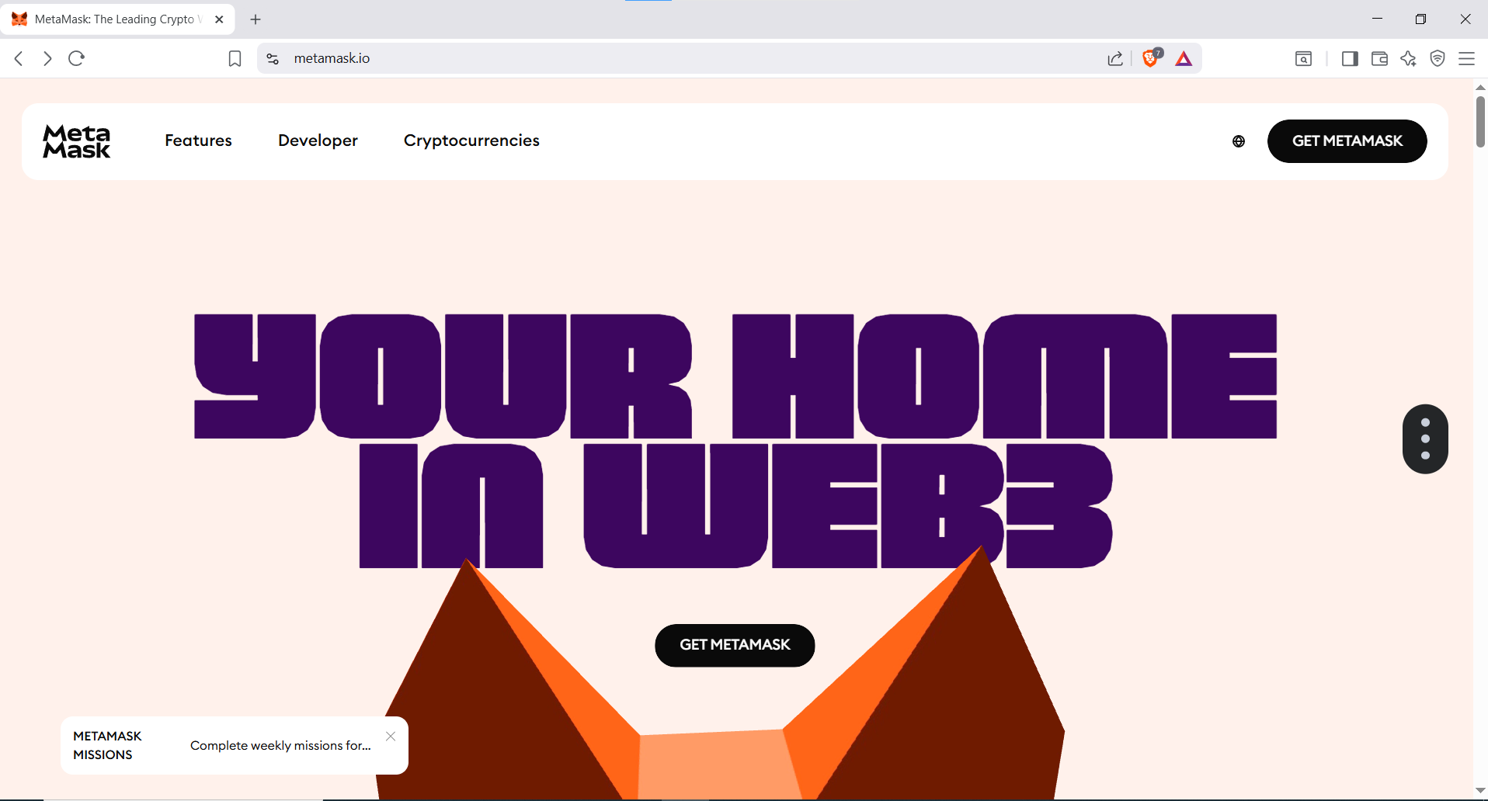

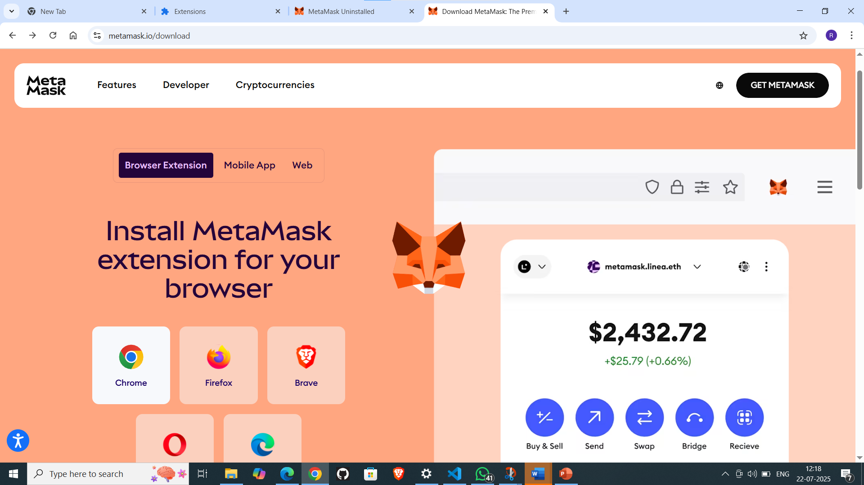

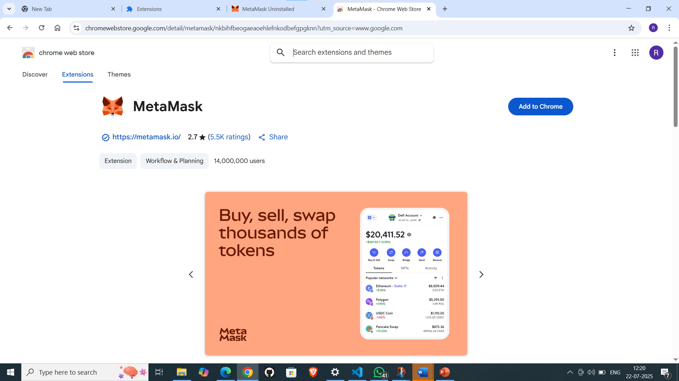

- Testing Phase: detection of Code (error detection)
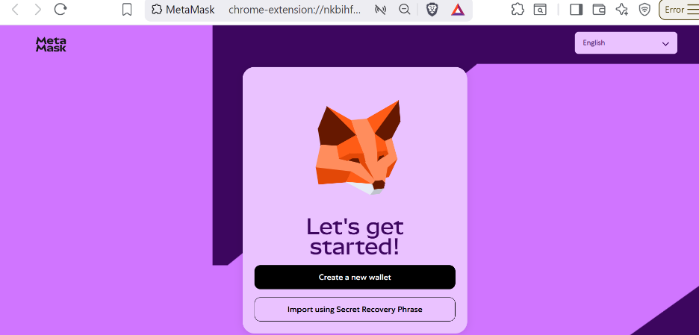

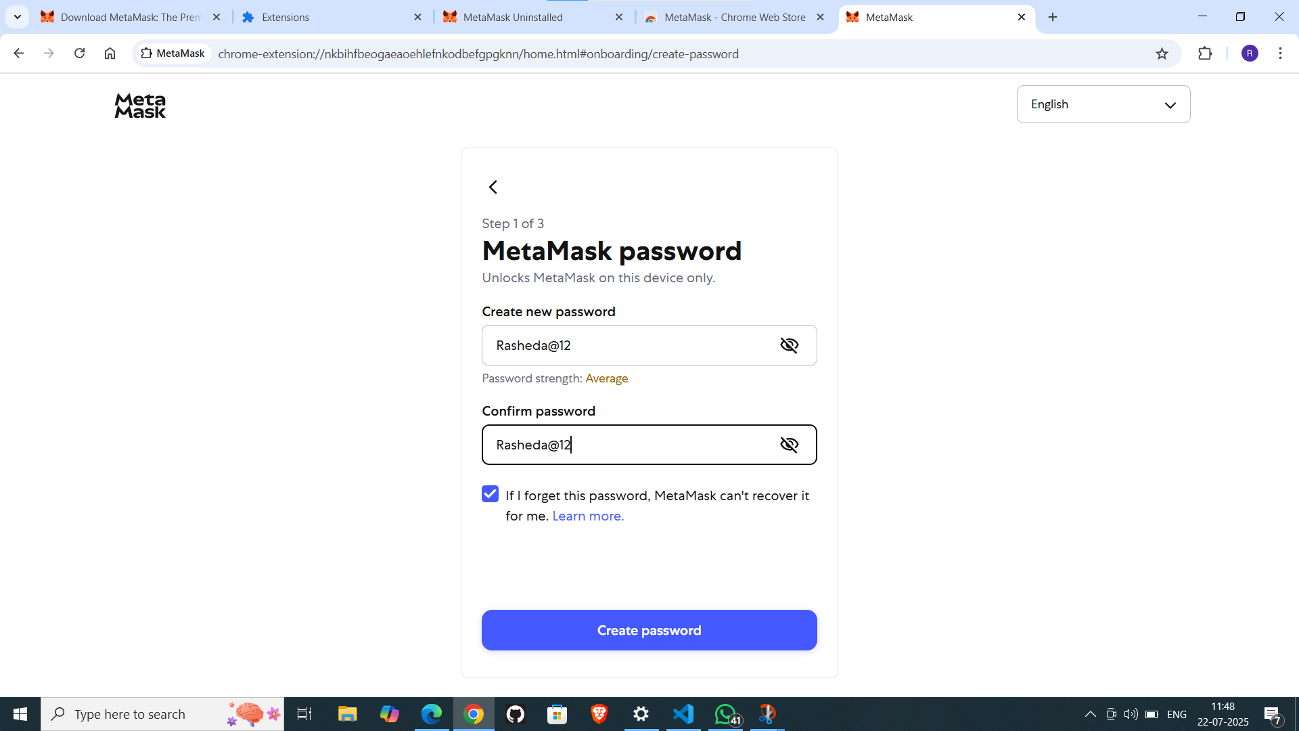

Testing Phase: detection of Code (error detection)
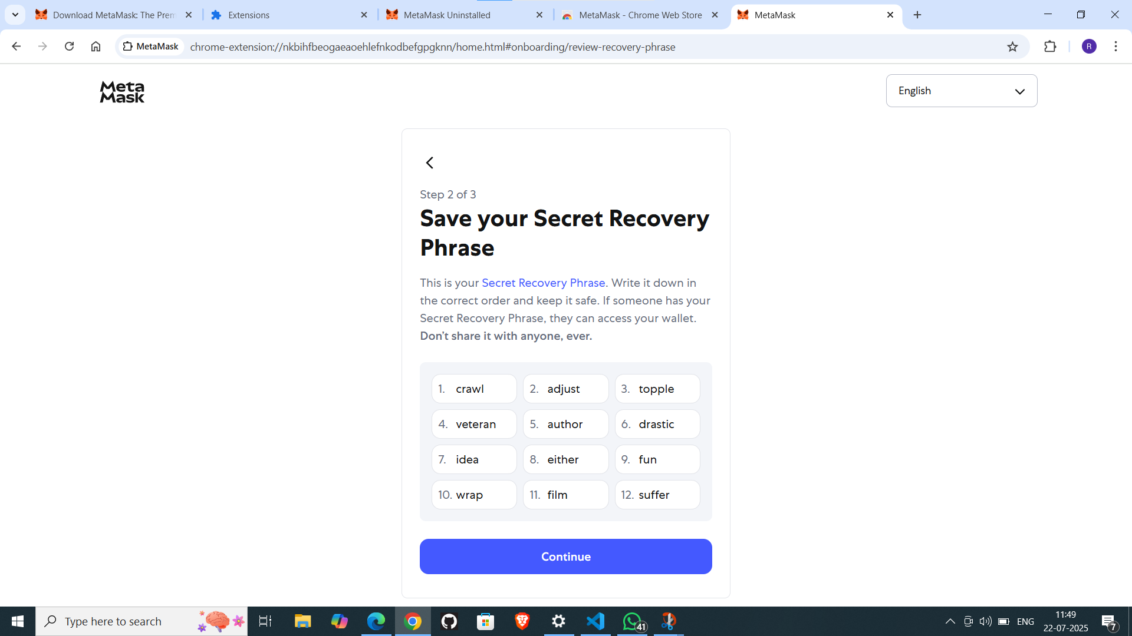

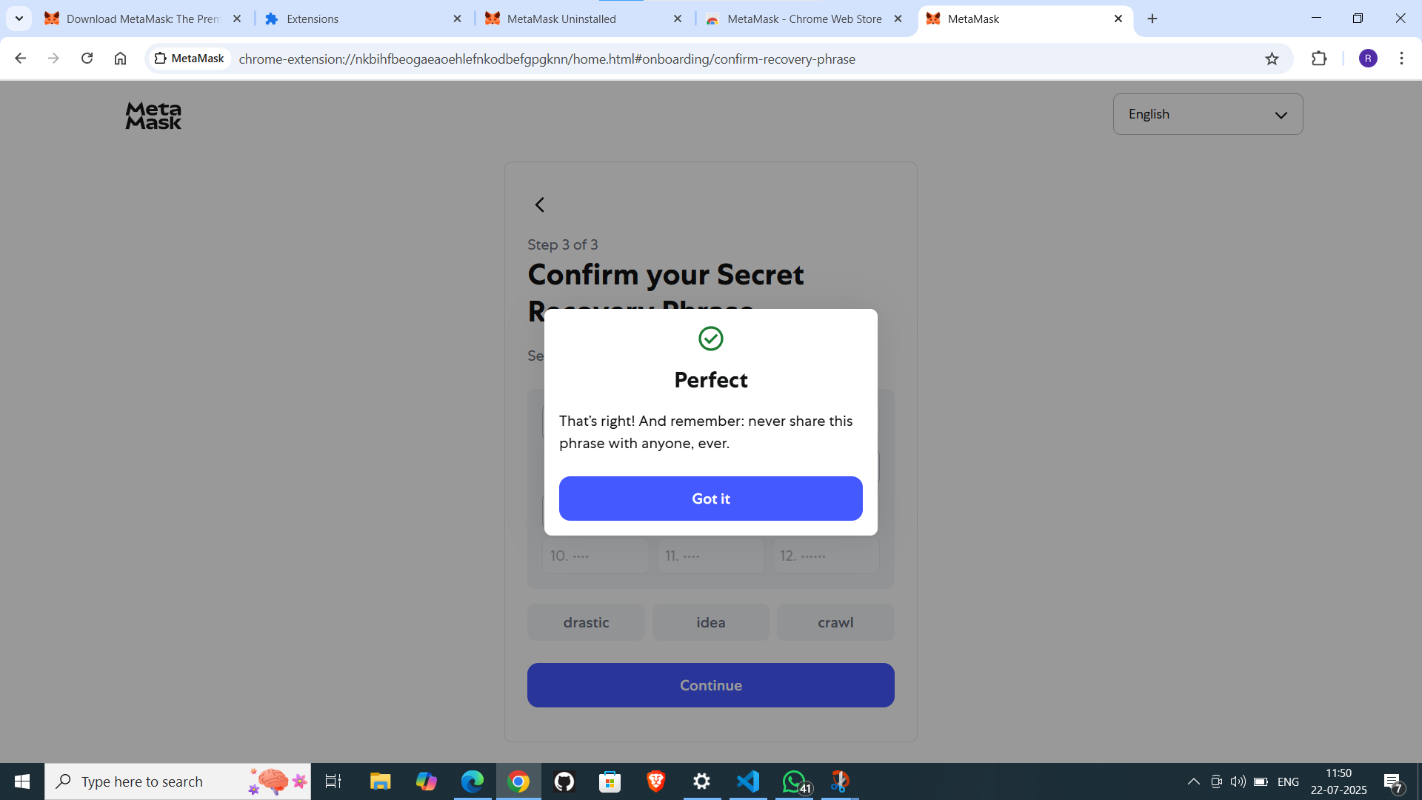

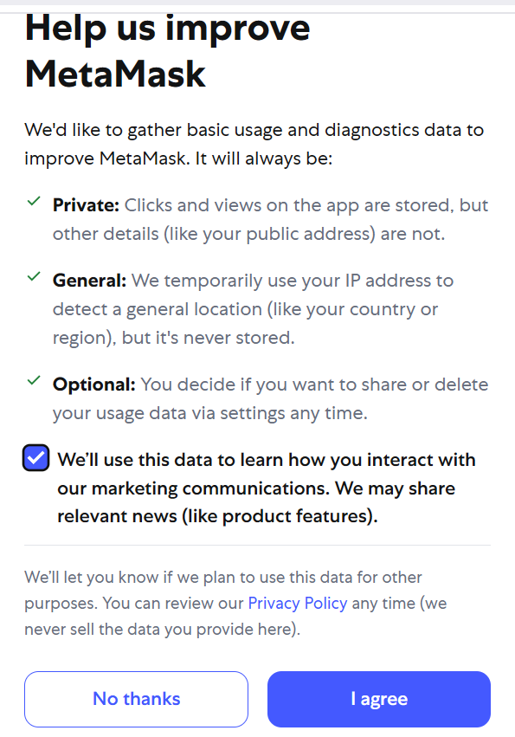

- Implementation Phase: Final Output (no error)
Applied and Action Learning

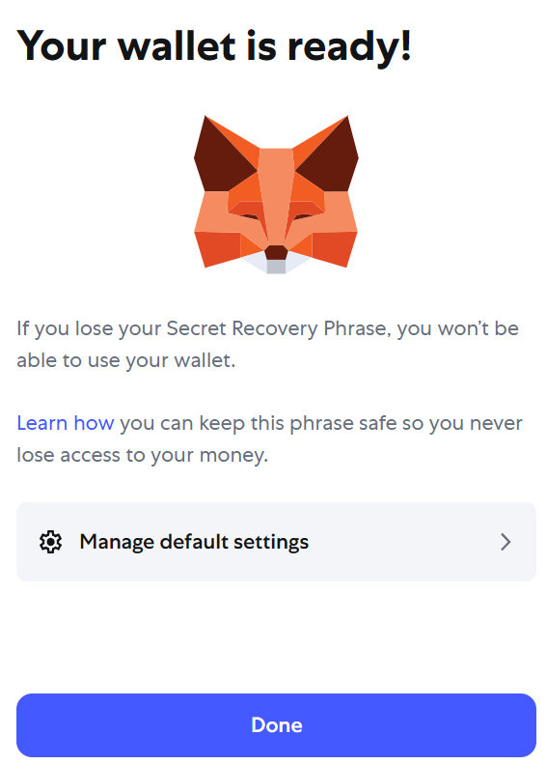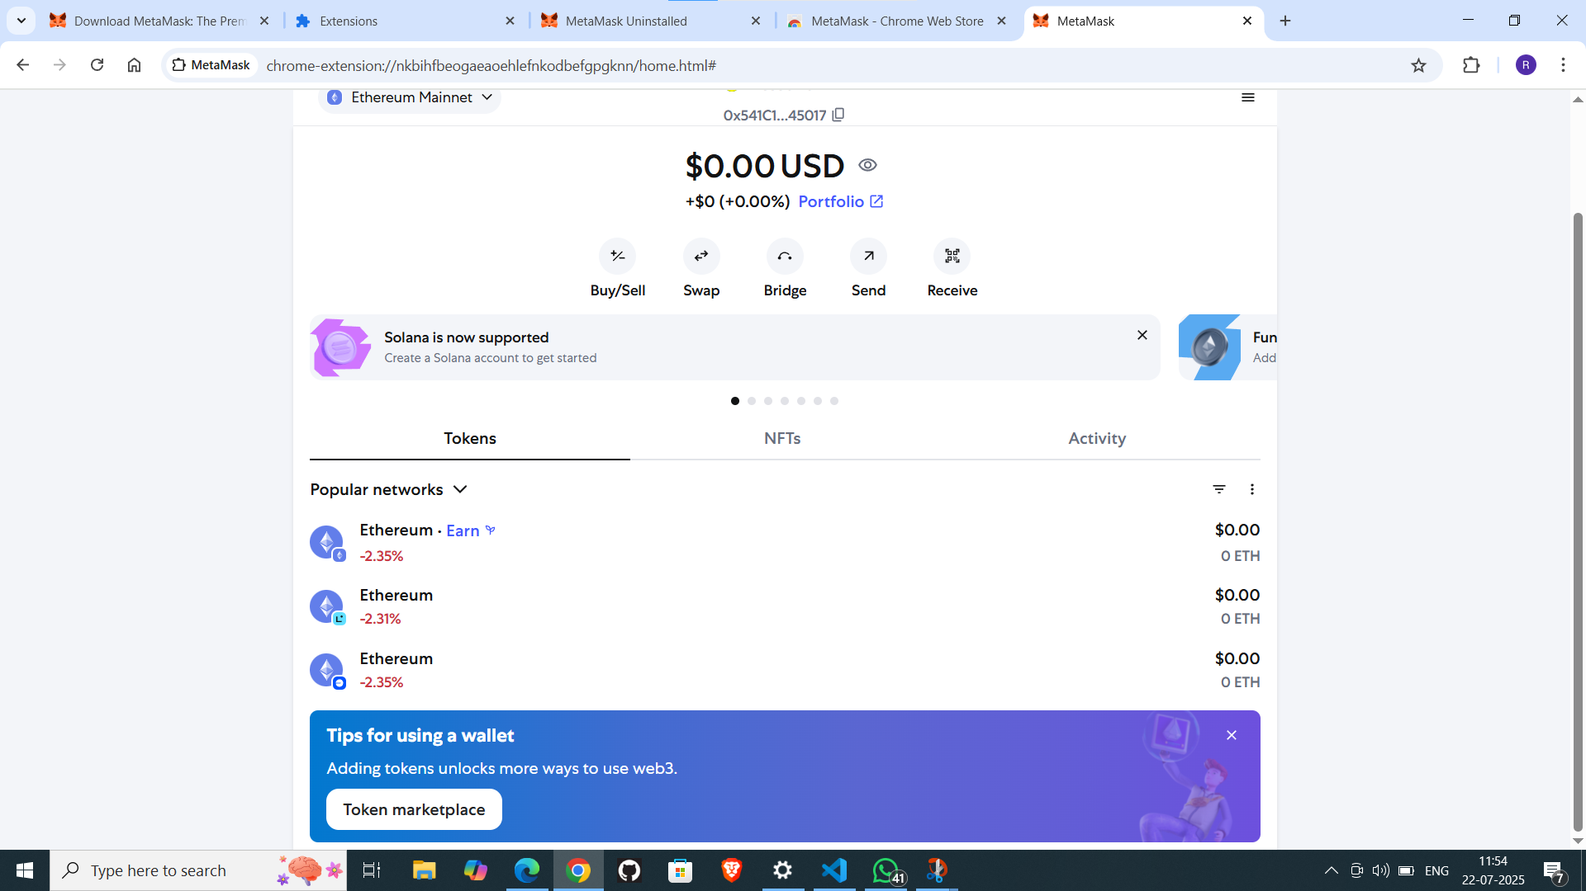

* Observations
- Seed phrase = master key.
- Password protects device, not a seed backup.
- Each wallet: public address (receive) + private key (sign).
- Address can be shared, private key must stay secret.
- Wallet stores keys, not coins.
- MetaMask = key manager + transaction signer.
- Network choice shows related blockchain data.

ASSESMENT

Rubrics
Concept | 10
Planning and Execution/  Practical Simulation/ Programming | 10
Result and Interpretation | 10
Record of Applied and Action Learning | 10
Viva | 10
Total | 50


Signature of the Student:
Signature of the Faculty:

